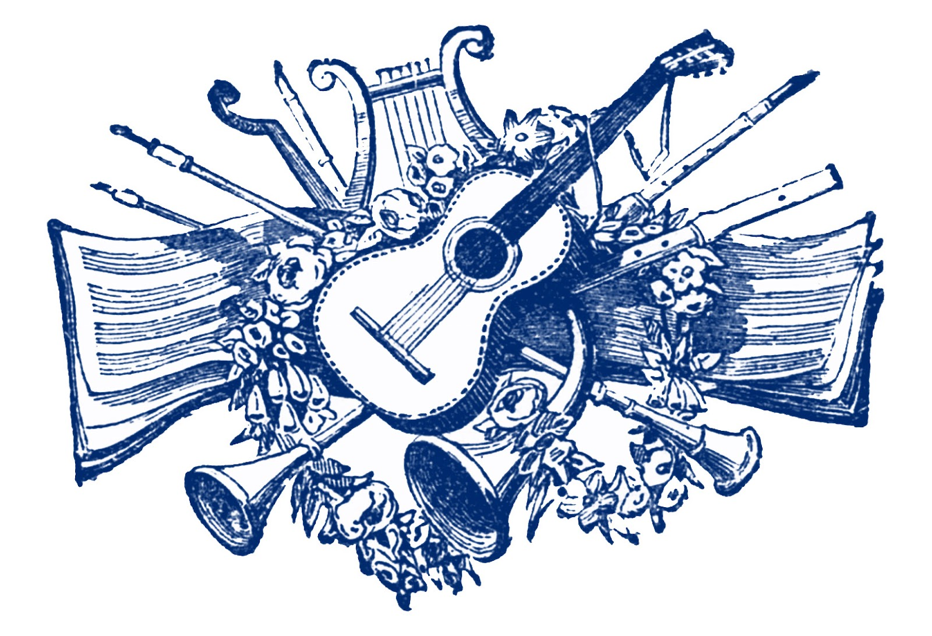

Listening to Classical Music
On the Internet
A Beginner’s Guide

Roderick A Smith

V1 May 2020

CONTENTS

Introduction

Musical eras

Renaissance

Baroque
Early
Middle
Late
Bach and Handel

Classical

Romantic

Modernisation

My Desert island Discs

Introduction

This project was put together during the lockdown enforced by the COVID-19 pandemic of 2020. For many people the internet became their window on the world, and many were to discover the wealth of material contained therein. Many orchestras made concerts past and present available on the web and these provided a much-needed escape from the tedium of days spent under what was (is as I write) virtual house arrest.

Music has given me so much pleasure during my life that when a friend asked my advice on what was “good to listen to” that I thought that making this project would serve as an interesting exercise for me and may give pleasure to others who chance to read it. I say, read it, because although there is much written material contained here, the main purpose is listening.

When I was young listening was from the wireless, a huge cabinet, powered by valves, which was a piece of furniture, or on a wind-up gramophone on which large shellac discs were played via the vibrations of a steel a needle amplified by a vast horn! Or we made music ourselves. I have very clear memories of having Sunday high tea at my maternal Grandma’s after which we would assemble round the piano in the sitting room. Grandad would play, we all had to perform our party piece. Grandad as far as I am aware had no formal musical training (but my sister doubts this). He learned to play the piano as live accompaniment for the silent pictures show in the village. And he was very good. I treasure a medal of his won from the College of Music in London. He played generally without music and had a repertoire which could satisfy our requests. One of my favourites was Liszt’s Hungarian Rhapsody. My sister had a sweet voice and later had singing lessons. Grandad tried to teach me to play the piano. I was more interested in kicking a football about because I was convinced I would become the centre forward for Manchester United. I made no progress with the piano (and very little with football!). It must have saddened the heart of Grandad. As I apologise to him now, I bitterly regret I am unable to play any musical instruments. Although, as they say, I have got rhythm, attempts with the violin and clarinet has been spectacular failures. This lack of musical performing ability is the greatest regret of my life, which generally and fortunately has been otherwise largely regret free. Rhythm was encouraged at infant school by the class listening to a wireless programme called Music and Movement and making movements suggested by the music

The first big piece of music that I became aware of was Messiah. My mother sang in the chorus was a local musical society, I remember being taken to a performance in the Coop hall in Oldham and being captivated. Messiah was ,and still is, a big northern tradition. “Ey up, tha knows, yon lass is a reyt fair singer wi t’Huddersfield”, was often heard on the other side of the Pennine Hills at my paternal Grandmothers. (Hello, you know that lady is a good singer with the Huddersfield Choral Society). Over the years I have heard Messiah in many venues and in many countries. Its universal and enduring appeal is amazing.

On arriving at grammar school, aged 11, I was immediately placed in the Choir. We were coached by a fierce, but not very learned, music master, Sid Jones, “Stop fidgeting Smith. I will have you thrashed to within an inch of your life”. He never did, but he kept a sharp eye on the choir via a strategically placed mirror attached to the organ. Every day we led the singing of a hymn during Assembly. I still automatically go into the breathing mode we were taught for the well-known hymns taken from Songs of Praise, a copy of which we had to buy from the school office. Under threat of severe punishment, I learned six verses of the school hymn, Veni Creator Spiritus, in Latin, overnight. I can still recall them now and enjoy the descants of the second and sixth verses. There were big occasions in the school calendar: the Christmas Carol service, Founders Day, Speech Night, and memorably, Remembrance Day. The Choir was fitted out in white starched surpluses borrowed from the local church. Music and occasions to remember.

We were taken from school to Hallé concerts in the Free Trade Hall in Manchester. This was an introduction to classical music played live. At first a little reluctant, my enthusiasm was quickly kindled. Our accompanying Latin Master said after a rather difficult first half, “Don’t worry its Brahms to come, you will enjoy that”, and I did. Sir John Barbirolli was the Conductor of the Hallé. He was very faithful to Manchester and the Hallé despite many attractive offers from elsewhere. And the audience loved him. He used to walk slowly towards the podium, appearing rather scruffy ,as he accepted the warm applause. Suddenly, he would swivel round, fling his baton in the direction of the drums and the cymbals, which would crash out the opening of the National Anthem. The hair on the back of my neck would rise. What a fine, formal way of starting a concert: we seem to have lost that harmless patriotism today. We were usually seated very near the front and could here Barbirolli humming and moaning in a way which seemed to bear little or no resemblance to the music.

My greatest Hallé experience was a performance of Elgar’s Cello Concert by Jaqueline Du Pre, conducted by Daniel Barenboim. More of this remarkable experience later.

My undergraduate days at Oxford were enhanced by many experiences which have enriched my life. Important amongst them were the meetings of a small group of us at St John’s College, gathered after lunch or dinner for coffee and to listen to music from a gramophone (by now electric). These sessions greatly extended my listening repertoire. My first hearing of Faure’s Requiem, introduced by Roger Looser, no sadly deceased, is an abiding memory.

Over the intervening years, I have attended many concerts, and never failed to be thrilled by the joy of live music. Luckily my wife shares this enjoyment. I wooed her by posting cassettes of my favourite pieces to her in Japan from my home in Cambridge. It must have worked. She would listen and reply with an airmailed letter from Tokyo which I read several weeks after posting the cassette. How the speed of communication, and the cost, has reduced!

So, this is why I have called this study, Listening to Classical Music On the Internet
A Beginners Guide. We are going to use the internet to listen to a wide variety of music. Thanks to the miracles of the chip, the miniaturisation of electronic equipment and the huge reduction in cost, you can listen directly on a computer or phone, use external speakers if you wish, or cast to your TV via a dongle. If you need advice, lots of it is on the net!

We will make extensive use of Wikipedia and You Tube. Signing up to Spotify may be very useful. It all there free as long as you have a decent connection to the net. The wonders of modern technology! Please enjoy!

And don’t worry if you know nothing about the structure of music. This is about listening, enhanced, I hope, by stories of the composers, and enough links to further information if you want to satisfy your curiosity and extend your knowledge. And don’t worry about the technology of the instruments. It is enough to know that we hear music via vibrations transmitted to our ears through the air. There are three basic actions, blowing, scraping and banging! Trumpets and clarinets are blown, violins and other stringed instruments are scraped, whilst the percussion drums and cymbals are banged! The miracle of music is that it all comes together with such pleasing effect.

But essentially, this is my choice of music which suits my own taste. As is often said about art appreciation, I know what I like, and I make no value judgement of what I don’t like!

But I do hope you too will enjoy what I have chosen to illustrate this introduction to Classical Music.

Musical eras

To introduce this huge topic I have found it convenient to use the well-recognised eras of classical music.

I am starting at the Renaissance era. So there is a very heavy emphasis on Western European music and for many centuries an entanglement with Christianity. I know, of course, that there are musical traditions in other parts of the world, but it is too difficult to cover them in a brief survey like this. Later contributions to the corpus of classical music have come from the New World.

The early composers were largely male. But as time went on many more females became performers. Even so it is striking to see famous orchestras in the post-World War II era still predominately elderly males. This has now changed, and females are well represented in orchestras, there are many superb lady solo instrumentalist and many female conductors. Today Western music is performed all over the world and many superb orchestras and soloists have emerged from the Far East.

Let’s start with Renaissance music.

This period, c. 1400 -1600, in Western Europe, typically beginnings of classical music, aided by the printing press to distribute music and words and the development of reliable musical instruments.

https://en.wikipedia.org/wiki/Renaissance_music

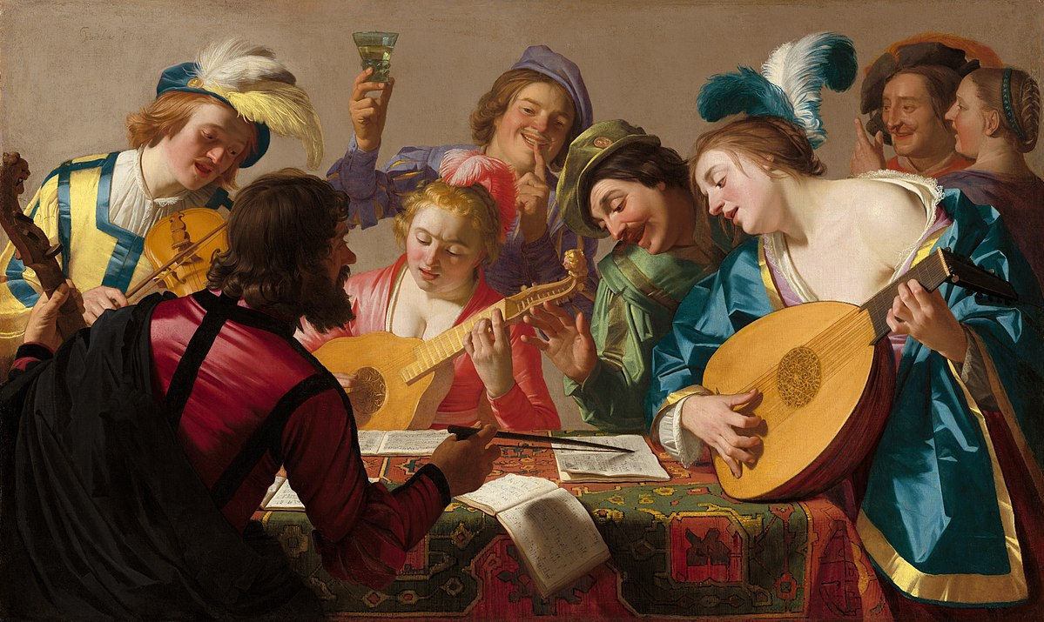 | Renaissance music - Wikipedia  en.wikipedia.org

If interested in details, follow the link above, but for enjoyment, let us listen to examples:

A compilation:
https://www.youtube.com/watch?v=FEBO1ibzSX4
listen particularly to the part singing for 4, 5, 6 voices

Another for the lute, particularly easy listening:
https://www.youtube.com/watch?v=o2nr401xYTM

The Renaissance period, simplicity of sound, but complexity of the combinations of voice and instruments.

Relaxing music, gentle on the ear, settling for the emotions. But the birth of modern western music tradition.

Let’s move onto Baroque Music, a study in four parts.

We have a huge embarrassment of riches here, so it is convenient that we can divide the Baroque period lasting from 1700 -1850 into three phases, Early, Middle and Late, each of approximately 50 years duration.

I will deal with each part separately, and in addition give a whole separate section to the late baroque masters, Handel and Bach.

Two things of particular note. This period marked the beginnings of the modern orchestra. The quality of instruments improved, strings, wind and percussion became separate groups of the ensemble. The organ came to prominence. The characteristic instrument, the harpsicord, was much employed.

Music had a close association with, and patronage from, the church. Settings of the Mass became an expression of homage to the Christian ideas which dominated Western Europe.

Early Baroque
The age of flourishing on Florence and Venice;

Gabriela: Suscipe – The outstanding boys Choir of King's College Cambridge, in the beautiful King’s College chapel Cambridge, where I have listened to so many magic moments of music.
GABRIELI: Canzon Seconda for Four Trumpets
The trumpet was much played in this era.

Listen to Sir John Eliot Gardiner taking about the
The genius of Monteverdi

Here Harry Christophers explains the beauty of the vespers, sung by his Choir
The Sixteen: Monteverdi Vespers of 1610
The Sixteen have been the special guest performers at many Christmas Dinners at the Oxford and Cambridge Club: marvellous Choir!

Orlando Gibbons was born in Oxford, lived in Cambridge and was organist at Westminster Abbey.
Listen to this wonderful setting of the Magnificat, still at the centre with Nunc Dimmitis of Christian worship.*
Orlando Gibbons, Magnificat
And this much longer collection of his works:
Orlando Gibbons - The Best of Choral and Organ works

To end this Early Baroque section, we consider Heinrich [Henrich] Schütz of Dresden was a German composer and organist, generally regarded as the most important German composer before J.S. Bach .
Try his Magnificat anima mea
Italy, England, Germany, European birthplaces of Baroque music in the early eighteenth century.

*The Magnificat is so important in Christian worship today that it is worth recalling the English words:

My soul doth magnify the Lord,
and my spirit hath rejoiced in God my Saviour.
For he hath regarded the lowliness of his handmaiden.
For behold, from henceforth all generations shall call me blessed.
And his mercy is on them that fear him throughout all generations.
He hath shewed strength with his arm.
He hath scattered the proud in the imagination of their hearts.
He hath put down the mighty from their seat
and hath exalted the humble and meek.
He hath filled the hungry with good things.
And the rich he hath sent empty away.
He remembering his mercy hath holpen his servant Israel
as he promised to our forefathers Abraham, and his seed forever.
Amen.

Baroque: Middle period

During which music begins to be much more recognisable in its modern from. We are spoilt for choice as there are so many works which are bright, thrilling, tuneful and easy on the ear. What follows does not attempt to be comprehensive.

François Couperin of Paris, composer, organist and master of the keyboard. For general details of his life, see
https://en.wikipedia.org/wiki/Fran%C3%A7ois_Couperin
and listen to the links to examples of his music on this site.
For a longer example of his work listen to Couperin: Complete Chamber Music

Arcangelo Corelli was an Italian violinist and composer of the Baroque era. His music was key in the development of the modern genres of sonata and concerto, in establishing the pre-eminence of the violin, and as the first coalescing of modern tonality and functional harmony.
Here is a fine example: Concerto in D Major Op. 6 No. 4,

Marc-Antoine Charpentier of Paris. Listen to his Te Deum. The prelude is the tune we associate with EuroVision, from the days when a live broadcast from Europe was an event, unlike the instant global coverage we have become used to! Note the Latin text is given below the video.

Henry Purcell was one of the greatest English composers. Organist of Westminster Abbey and of the Chapel Royal. Everyone knows his Trumpet Tune,
But his Ode to St Cecilia was one of his most famous works. St Cecilia merits our attention as is the patron saint of musicians!

As a finale to this section here we have the incomparable Alison Balsom with Sound the Trumpet: Royal Music of Purcell and Handel, the latter a taster of some wonderful music to come!

Late Baroque

We are now embarrassed by a surfeit of riches. Here we listen to samples of the works of just some of the greatest composers of this era. Italy provided the majority, but by no means all.
It is worth going back to reread the link to Baroque music given at the beginning of the first Baroque section.

- Alessandro Scarlatti the red haired priest. Listen to his piano sonatas whilst learning about him on this link. Here is his Messa di Santa Cecilia
- Antonio Vivaldi , everyone knows his Four Seasons! Try his Gloria at La Pietà Venice, then his greatest hits!
- Tomaso Albinoni, complete Oboe Concertos and his Adagio in G Minor
- Benedetto Marcello Oboe Concerto in D minor

- Pietro Locatelli Capricci for Solo Violin

- Giovanni Battista Pergolesi Stabat Mater with Emma Kirkby, and Magnificat in C major
- Georg Philipp Telemann Overture 'Burlesque de Quixotte The Best of Telemann

After this feast of music, remember I have promoted Bach and Handel, who properly belong to the Late Baroque period, to a separate section of their own, coming next.

Setting of the Mass are a feature of the work of many of the composer we have, and will, consider, so it is worth reading this note on the Mass and its choral composition.
. Kyrie
Gloria
Credo
Sanctus and Benedictus
Agnus Dei

Bach (1685-1756) and Handel (1685-1759): The Masters of Baroque

Best Bach Works: 10 Essential Pieces By The Great Composer

Bach’s St Matthew Passion: A Guide To The Sacred Masterpiece

Goldberg Variations. Glenn Gould plays Bach

Concerto for two violins in D minor

Toccata and Fugue in D minor

Best Handel Works: 10 Essential Pieces By The Great Composer

Messiah: Masterpiece Guide To The Great Choral Work

The Cuckoo & The Nightingale

SEE, THE CONQU'RING HERO COMES!. Judas Maccabaeus

Beethoven Twelve Variations See the Conquering Hero Comes

Thine Be the Glory

Handel’s Fugues

TO BE CONTINUED

The Covid-19 pandemic is still raging, and the country is under lockdown once more.
Mass vaccination is underway, I was inoculated with the so-called Oxford vaccine last week.
It is to be hoped that some kind of normal life will soon return.

8 February 2021

